User Defined Type in C#

In C#, you get two types of data type:
- Primitive data type (int, double, string etc.)
- User defined type (Employee, Customer, Member, Loan, etc.)

Also .Net framework has lots pre-made types (Console, Form, Convert, Button etc.) which can be used in C#.

You have been already familiar with primitive type and some data types provided by .Net framework. In this lesson, you will make your own data type and use these for solving your problem.

Consider the following example:

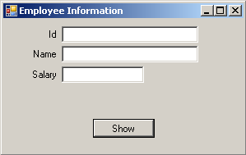

Figure 1: Employee information user interface

Here, user will enter employee’s information (See Figure 2) and press ‘Show’ button, all information will be cleared from textboxes and will be shown in a Messagebox as shown in Figure 3.

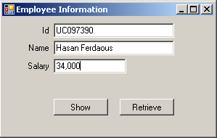

Figure 2: User enters employee’s information

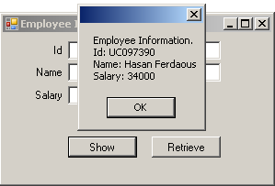

Figure 3: After pressing ‘Show’ button user will see the employee’s information in a MessageBox.

Already all data has been cleared from textboxes. But when user will press ‘Retrieve’ button, he will get the employee information into related textboxes (See Figure 4)

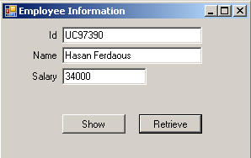

Figure 4: Pressing ‘Retrive’ button user will see employee’s information in textboxes which has been entered just before.

If you use primitive data type your code might be as follows (Open the solution inside User Define Type\EmployeeExample\PrimitiveType)

public partial class EmployeeInformationUI : Form
{
private string id;
private string name;
private double salary;

public EmployeeInformationUI()
{
InitializeComponent();
}

private void retrieveButton_Click(object sender, EventArgs e)
{
idTextBox.Text = id;
nameTextBox.Text = name;
salaryTextBox.Text = salary.ToString();
}

private void showButton_Click(object sender, EventArgs e)
{
id = idTextBox.Text;
name = nameTextBox.Text;
salary = Convert.ToDouble(salaryTextBox.Text);
ClearEmployeeInformationFromTextBoxes();
MessageBox.Show("Employee Information." + "\nId: " + id +
"\nName: " + name + "\nSalary: " + salary);

}

private void ClearEmployeeInformationFromTextBoxes()
{
idTextBox.Text = "";
nameTextBox.Text = "";
salaryTextBox.Text = "";
}
}

Here, three variables: id, name as string and salary as double have been declared. these variables have been outside of all methods to get the access in all methods.

The above code is self-descriptive and so description is not needed.

Interesting thing is that the above example can be solved by creating your own data type.

It is possible to keep several data (related) in a single user defined type data. Here, employee id, name and salary can be placed in a single user defined data type. Suppose the name of this type is Employee.

Follow the steps to solve the problem by using user defined data type:

- Click right button on the project
- Click Add>Class
- In Name TextBox, type Employee.cs and press ‘Add’ button

You will see Employee.cs in solution explorer and see the following code inside Employee.cs file:

class Employee
{

}

Update the Employee class as follows:

class Employee
{
public string id;
public string name;
public double salary;
}

Then update your previous code as following code:

public partial class EmployeeInformationUI : Form
{
Employee employeeObj = new Employee();

public EmployeeInformationUI()
{
InitializeComponent();
}

private void retrieveButton_Click(object sender, EventArgs e)
{
idTextBox.Text = employeeObj.id;
nameTextBox.Text = employeeObj.name;
salaryTextBox.Text = employeeObj.salary.ToString();
}

private void showButton_Click(object sender, EventArgs e)
{
employeeObj.id = idTextBox.Text;
employeeObj.name = nameTextBox.Text;
employeeObj.salary = Convert.ToDouble(salaryTextBox.Text);
ClearEmployeeInformationFromTextBoxes();
MessageBox.Show("Employee Information." + "\nId: "
+ employeeObj.id + "\nName: " + employeeObj.name +
"\nSalary: " + employeeObj.salary);
}

private void ClearEmployeeInformationFromTextBoxes()
{
idTextBox.Text = "";
nameTextBox.Text = "";
salaryTextBox.Text = "";
}
}

In primitive data type example, we use three variables to store employee information in our application.

private string id;
private string name;
private double salary;

But here, we replace these three variables by a single variable, employeeObj.
employeeObj variable is an Employee type, which is a user defined type. Actually, three data of an employee has been embedded inside employeeObj variable.

Employee employeeObj = new Employee();

The above line is very simple as any other primitive data type such as

int noOfStudents = 30;

Compare these two lines. In second line, your variable name is noOfStudents, in first line variable name is employeeObj. In second line, variable type it int, whereas in first line type is Employee. In second line you initialize noOfStudents by 30, in first line you initiialize employeeObj by the instance (or object) of Employee type.

Practice-1:

Open the solution file StudentInformationPrimitiveDataType located in Basic Practices folder. Here, the code has been written using primitive type. Find a User Defined Type here (guess what) and follow the above example (employee information) to replace variables with this type.

See the solution StudentInformationUsingUserDefinedType located in Basic Practices

Method inside User Defined Type:

If you see the provided solution of Practice-1, you will get Student as a user defined data type and this type is used in StudentInformationUI class.

In the third example, StudentInformationUsingUserDefinedTypeWithMethod
inside StudentExample you will see a method, GetFullName() in Student data type and this method is used in MessageBox. So, you see, it is possible to write method inside a user defined type.

